**ALL THE TABLES AND COLUMNS OF SAMPLENORTHWIND DATABASE**

1. **PRODUCTS TABLE**

SELECT * FROM Products ;

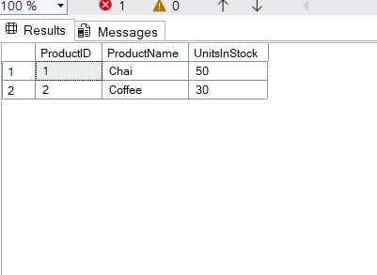

1. **ORDERS TABLE**

SELECT * FROM Orders ;

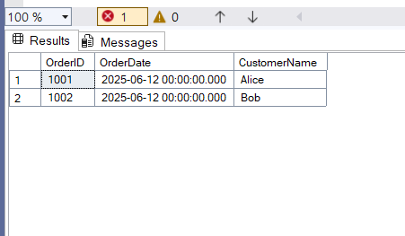

1. **ORDERDETAILS TABLE**

SELECT * FROM OrderDetails;

